Fire/Tornado/Safety Drill Completion Documentation

Building Name: Whitmore Lake High School

School Year:

Date: 03.22.2018

Time: 9:07am

Type: xx Fire Tornado Safety

Location: Classroom Lunch Recess x Other

Number of Completed Drills: 4 Fire 2 Tornado 3 Safety

Name of Person in Charge of the Drill :
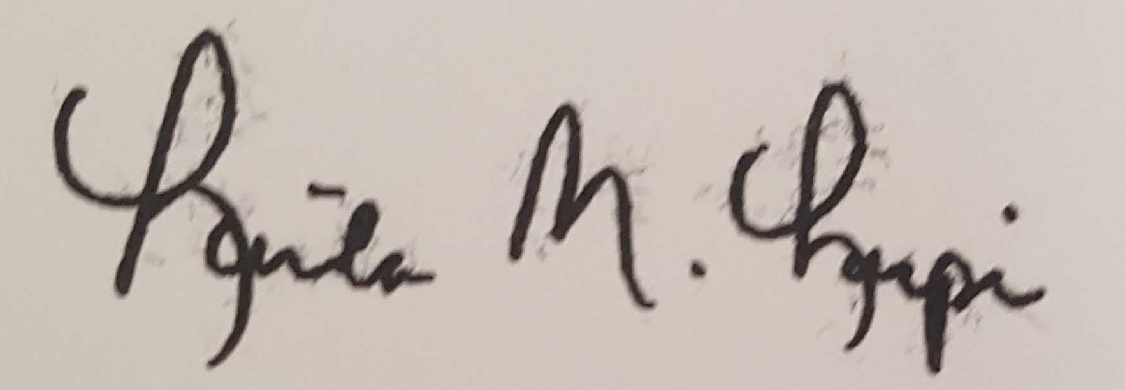
Signature of Principal Acknowledging Completion:

Fire Drills Safety Drills
● 5 Per Year ● 3 Per Year
● 3 Before December 1 ● 1 Before December 1
● 2 During Remainder of School Year ● 1 After January 1
● 3 Before December 1
Tornado Drills ● Seek Input from Local Public Safety Officials
● 2 Per Year
● 1 During Month of March

Other Requirements
● 1 Drill During Lunch, Recess, or Time When are Not in Classrooms
● List of Scheduled Drills to County Emergency Management Coordinator by September 15
● Drill can be Cancelled for Sever Storm, Fire, Epidemics, Utility Outage, Water Failure, Sewer
Failure, Health Conditions
● A Cancelled Drill Must be Scheduled within 10 Days of the Cancelled Drill
● Documentation of a Drill Must be Placed on the Website Within 30 Days of the Drill
● Drill Documentation Must Remain on the Website for 3 Years

